Encryption RSA/GPG
What I did
- Opened OpenSSL on git bash using the OpenSSL code (OpenSSL version)
- Downloaded tux.png
- Went to downloads on Git Bash using cd ~/Downloads
- I then hit ls to see if tux.png appeared on my system
- I created the files openssl enc -aes-128-cbc -salt -in tux-96.png -out tux_cbc.enc,
- openssl enc -aes-128-ecb -salt -in tux-96.png -out tux_ecb.enc,
- openssl enc -aes-128-ofb -salt -in tux-96.png -out tux_ofb.enc
- Then I had to make sure that the files were created so I did the code ls which showed the list of my files that were created.
- I uploaded it in notepad, and it was all special letters, letters scrambled.
- Then I uploaded the files to give to the Data and encoding person

RSA/Gym Video
- RSA works generate two random prime numbers, two very large prime numbers
- When a message is sent using RSA you are going to get it over the internet
- People would see all these numbers when sending them over the internet
- An attacker will get to see n, e, c which is all their numbers
- If the numbers are large, then it is harder to break. So, if the private key is large numbers, it makes the hard to break from the attacker.
- That way the RSA those p and q are very large
- RSA each person has 2 keys

Symmetric Encryption
- With Symmetric Encryption the sender and the receiver must both have a because it is the only way to read the message.
- So, the person with the key and the message is going to take both and run it through a symmetric encryption algorithm and send it to the other person.
- Since the other person already has the key, he can combine the encrypted message with the key using the decryption function and get back to the plain text.
- The key is your password if they have a key, they can decrypt your message

Asymmetric encryption (RSA)
- Asymmetric encryption and that’s why RSA were created
- Instead of having one key that both people use we have 4 keys
- Each person has a public key and private key
- Use private to decrypt any messages
- So, if a person 1 wants to send a message to person 2 then person 2 will take person 1 public key encrypts the message sends it to person1 and they will use their private key to decrypt the message

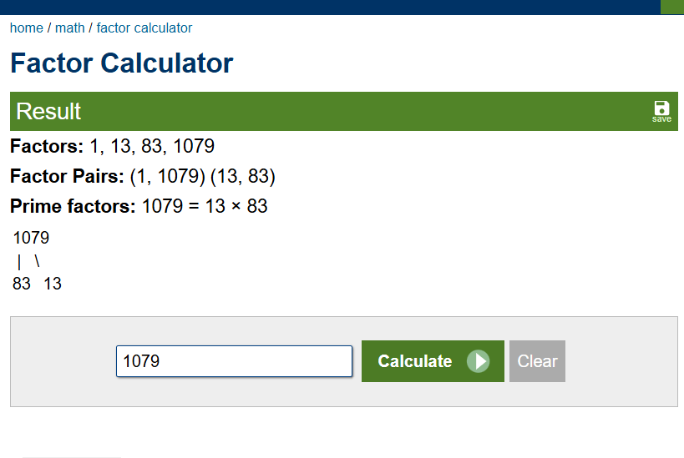
- Which we take the formula
- picked two prime numbers (p and q)
- p=83
- q=13
- N=p x q
- N= 83 x13
- N=1079
- Now we use the formula
- D x e= 1 mod (p-1) (q-1)
- We plug in p and q
- N= (83-1) (13-1)
- N=82 x 12
- N=984
- Since E is given to us because it is a public key
- E= 43
- Now find out D
- D x e= 1 mod
- D x 43=1(mod 984)
- Used RSA Calculator: d = 595
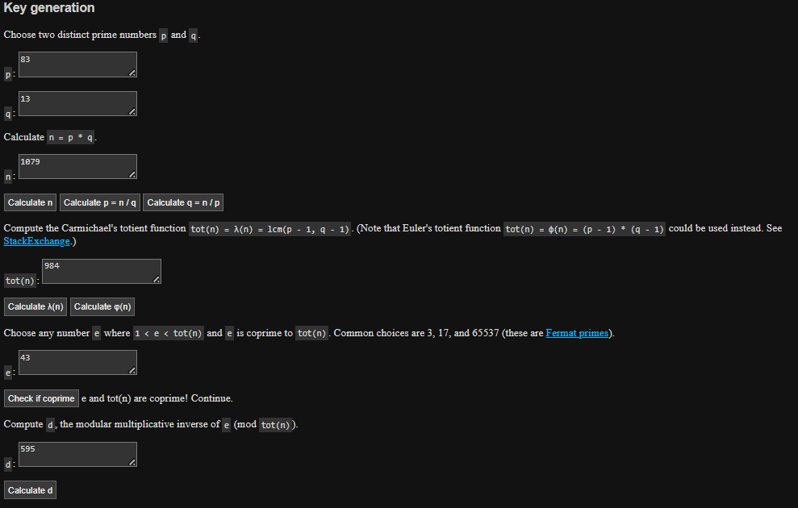

- Decrypt the ciphertext formula m=c^d (mod n)
- M= 996^595 (mod 1079)
- I got 996 from c
- M=83

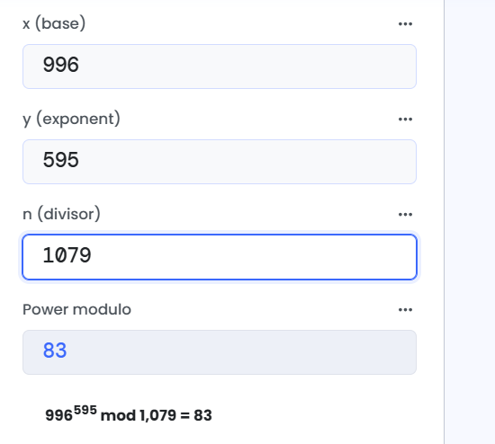

- And then on the ASCII table when you search for 83 the first character is S
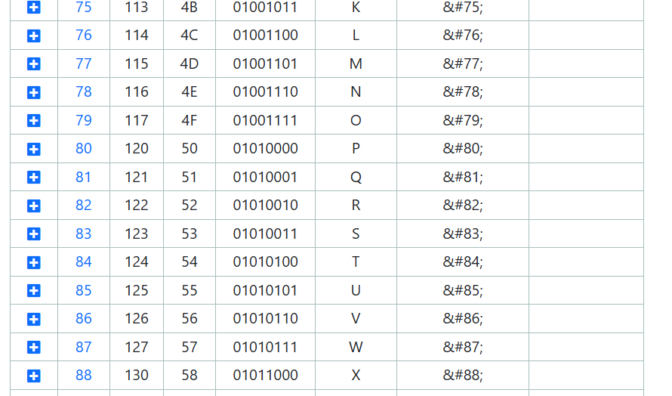

- Pasting my file in CyberChef was unreadable
